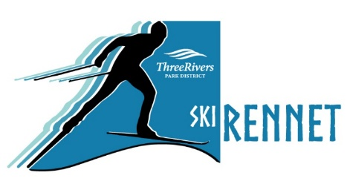
Pioneer Midwest 6K High School Rennet
Hosted by
Registration Form

Mail to Three Rivers Park District, High School Rennet,
2330 County Road 19, Maple Plain, MN 55359.
Registrations must be received by January 16.

For more information, visit ThreeRiversParks.org/skirennet or
contact darla.smith@threeriversparks.org or darren.dummer@threeriversparks.org.

Please write legibly.

Skier’s Name ________________________________________ Skier’s School ________________________________________

Technique Classic Freestyle Division Men’s Women’s Registering with a team? Yes No
JV Varsity

Address _____________________________________________ City, State, Zip __________________________________________

Email __________________________________________

Emergency Contact _______________________________________ Relationship ________________ Phone ______________________

WAIVER OF LIABILITY: I acknowledge that by participating in a race sponsored by Three Rivers Park District, I am exposing myself to certain risks which could result in personal injury or property damage. I hereby assume such risks and agree to release Three Rivers Park District from any claims arising from the inherent risks of such activities. In consideration of Three Rivers Park District providing me with the opportunity to participate in this contest, I hereby agree to release Three Rivers Park District from claims of personal injury or property damage caused by the actions of Three Rivers Park District, its directors, officers, employees, and agents.

Signature Required (by parent or legal guardian if under 18 years old Date

Additional Team Information: # personal vehicles: _________ # buses: _________

2018 Entry Fees July 10 – Jan. 16 Teams with 15+ Skiers
Teams* $10/skier $7.50/skier
Individuals $10.74/skier
*Team payments must be made by the school or Booster Club to receive the non-tax rate

Payment

Amount Paid __________ Check* Cash Credit/Debit Card – Phone number for payment: _________________________
*Please make checks payable to Three Rivers Park District.

